**HandsMen Threads**

**Elevating the Art of Sophistication in Men's Fashion**

**Abstract:**

In today’s digitally driven and fashion-forward world, there is a growing demand for premium, personalized, and sophisticated men's fashion. HandsMen Threads is a modern web-based solution aimed at redefining the shopping experience for men by combining elegance with convenience. The project offers a stylish, intuitive platform where users can explore curated fashion collections, place orders, and engage with loyalty programs — all supported by robust backend systems such as inventory management and CRM integration.

This project bridges the gap between fashion and technology, employing tools like Salesforce for order flow automation, real-time inventory alerts, and campaign management. Through dynamic user interfaces and seamless backend integration, the system ensures that customer satisfaction, operational efficiency, and brand growth are achieved simultaneously. With features like low stock notifications, personalized style recommendations, and a marketing engine powered by data, HandsMen Threads aims to elevate the art of sophistication in men’s fashion to a new digital standard.

**Introduction:**

In recent years, the fashion industry has experienced a digital revolution, with e-commerce and personalized experiences becoming the cornerstone of success. While women's fashion has long been the primary focus in retail, there is a rising demand for platforms that cater exclusively to men with refined tastes. HandsMen Threads was conceptualized to fill this gap by offering a dedicated digital space for sophisticated men’s fashion, supported by modern technologies and a seamless user experience.

This project is not just an online clothing store—it’s a complete fashion technology platform that includes inventory management, CRM tools, personalized marketing campaigns, loyalty systems, and order tracking powered by Salesforce automation.

**Key Highlights of the Project:**

* **Focused on Men’s Fashion:** A niche platform specifically tailored for modern and sophisticated men.
* **Web-Based Platform:** Easily accessible via web browsers on any device.
* **Salesforce Integration:** Used for order confirmation workflows, customer relationship management, and campaign tracking.
* **Inventory and Stock Management**: Real-time stock updates with low-stock alerts to avoid order failures.
* **Order Processing Automation:** Streamlined order confirmation, shipping, and delivery workflows using Salesforce flows.
* **Targeted Marketing Campaigns:** Personalized email campaigns and product suggestions based on user history.
* **Loyalty and Rewards Program:** Engaging features to retain customers and reward repeat purchases.
* **Secure and Scalable:** Built with scalability and data privacy in mind, ensuring safe and smooth operations.
* **AI-Powered Recommendations:** Personalized product suggestions based on trends and user preferences.

**Why This Project Matters:**

The fashion needs of men are often underserved in the digital marketplace. HandsMen Threads not only brings sophistication into design but also offers smart backend systems to support business growth. With an emphasis on user experience, business automation, and product elegance, this project is a blueprint for the future of men’s fashion retail.

Let me know when you're ready for the Objective section or want the full document built out for GitHub in one go.

**Objective:**

The primary objective of the HandsMen Threads project is to design and develop a smart, efficient, and user-friendly digital platform that transforms the way men engage with fashion online. By delivering a premium shopping experience focused on sophistication, personalization, and modern technology, the platform aims to become a go-to destination for stylish and quality-conscious male consumers. It blends elegance in design with functional technology to reflect the brand's commitment to refined fashion.

A major goal is to incorporate Salesforce CRM for seamless customer relationship management, automated workflows, and detailed sales insights. This enables the brand to track customer behavior, generate personalized campaigns, manage order flows, and improve engagement. The project also focuses on automating the order lifecycle—from product selection, cart management, and secure checkout to order confirmation, shipment tracking, and delivery notifications—ensuring a smooth user journey from start to finish.

Inventory control is another critical objective, where real-time stock updates and low stock alert systems are implemented to prevent shortages and delays. The integration of a loyalty program further enhances customer retention by offering points, discounts, and exclusive offers based on shopping behavior and engagement history.

In addition, the project aims to implement targeted marketing campaigns that are dynamic, data-driven, and tailored to individual preferences. This includes seasonal promotions, event-based offers, and influencer collaborations. Furthermore, by ensuring platform scalability and mobile responsiveness, HandsMen Threads is designed to serve a growing customer base across devices and regions.

Lastly, the system’s backend will be built with scalability and security in mind, allowing for future expansion, third-party integrations, and secure handling of personal and financial data. With a holistic focus on technology, fashion, and customer experience, this project seeks to position HandsMen Threads as a digital leader in sophisticated men’s fashion.

**Technology Description (Salesforce Developer Edition):**

The HandsMen Threads project leverages the powerful features of the Salesforce Developer Edition to build, manage, and automate the entire lifecycle of a men's fashion business — from inventory to CRM and marketing. The following Salesforce technologies are used:

**Salesforce Developer Edition:**

* Free, full-featured Salesforce environment for developing and testing applications.
* Supports custom objects, Apex code, Lightning components, and automation tools.

**Core Components Used:**

1. **Custom Objects**
   * Created for: Orders, Inventory, Products, Customers, MarketingCampaigns
   * Allows custom data modeling beyond standard Salesforce fields.
2. **Apex Programming**
   * Used to create custom business logic.
   * Enables triggers for automatic updates (e.g., low stock alerts).
3. **Lightning App Builder**
   * Used to design user-friendly, drag-and-drop UIs for the application.
   * Lightning Pages for Orders, Products, and Campaign dashboards.
4. **Salesforce Flows**
   * Automated workflows for tasks like order confirmation, customer notifications, and loyalty point updates.
   * Visual flows reduce the need for manual logic.
5. **Validation Rules**
   * Ensure data integrity (e.g., preventing out-of-stock orders, verifying user age for loyalty program).
6. **Reports & Dashboards**
   * Custom reports to monitor orders, product trends, inventory status.
   * Visual dashboards for quick insights by managers or sales teams.
7. **Email Alerts & Workflow Rules**
   * Automated email triggers for events like order confirmation, stock alerts, and promotional campaigns.
8. **Chatter & Notes**
   * Enables team collaboration and updates on customer orders or inventory changes.
9. **Salesforce Marketing Features** *(basic edition)*
   * Plan and track promotional campaigns.
   * Capture leads and customer interest via forms.
   * Used to bulk import product data, customer information, and inventory items.

**Detailed Execution of the Project:**

This section outlines each phase of building and executing the HandsMen Threads project using **Salesforce Developer Edition**. The project simulates the digital backend of a men's fashion business, managing everything from product catalogs to order management and customer engagement.

**Creating Developer Account :**

Creating a developer org in salesforce.

1.Go to <https://developer.salesforce.com/signup>

2.On the sign up form, enter the following details :

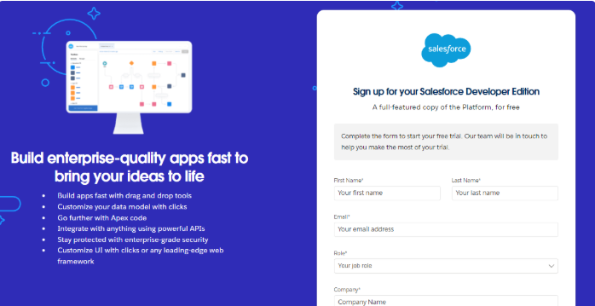

1)First name & Last name

2)Email

3)Role : Developer

4)Company : College Name

5)County : India

6)Postal Code : pin code

7)Username : should be a combination of your name and company

This need not be an actual email id, you can give anything in the format : [username@organization.com](mailto:username@organization.com)

Click on sign me up after filling these.

**Account Activation:**

1)Go to the inbox of the email that you used while signing up. Click on the verify account to activate your account. The email may take 5-10mins.

2)Click on Verify Account

3)Give a password and answer a security question and click on change password.

4)Then you will redirect to your salesforce setup page.

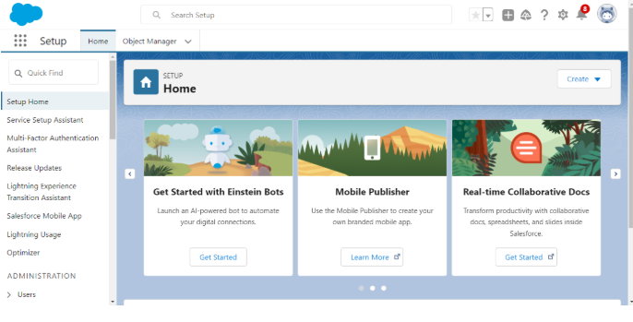

**To Navigate to Setup page:**

Click on gear icon → click setup.

**Activity 1: Create HandsMen Customer Object:**

To create an object:

1)From the setup page → Click on Object Manager → Click on Create → Click on Custom Object.

1)Enter the label name→ HandsMen Customer

2)Plural label name→ HandsMen Customer

3)Enter Record Name Label and Format

* Record Name → HandsMen Customer Name
* Data Type → Text

2)Click on Allow reports,

3)Allow search → **Save.**

**Create HandsMen Product Object:**

To create an object:

1)From the setup page → Click on Object Manager → Click on Create → Click on Custom Object.

2)Enter the label name→ HandsMen Product

3)Plural label name→ HandsMen Products

4)Enter Record Name Label and Format

* Record Name → HandsMen Product Name
* Data Type → Text

5)Click on Allow reports,

Allow search → Save

**Create HandsMen Order Object:**

To create an object:

1)From the setup page → Click on Object Manager → Click on Create → Click on Custom Object.

* Enter the label name→ HandsMen Order
* Plural label name→ HandsMen Orders
* Enter Record Name Label and Format
* Record Name → HandsMen OrderNumber
* Data Type → Auto Number
* Display Format → O-{0000}
* Starting Number → 001

2)Click on Allow reports,

Allow search → **Save**

**Create Inventory Object:**

To create an object:

1)From the setup page → Click on Object Manager → Click on Create → Click on Custom Object.

* Enter the label name→ Inventory
* Plural label name→ Inventorys
* Enter Record Name Label and Format
* Record Name → Inventory Number
* Data Type → Auto Number
* Display Format → I -{0000}
* Starting Number → 001

2)Click on Allow reports,

Allow search → **Save**

**Create Marketing Campaign Object:**

To create an object:

1)From the setup page → Click on Object Manager → Click on Create → Click on Custom Object.

2)Enter the label name→ Marketing Campaign

3)Plural label name→ Marketing Campaigns

4)Enter Record Name Label and Format

* Record Name → Marketing CampaignNumber
* Data Type → Auto Number
* Display Format → MC -{0000}
* Starting Number → 001

5)Click on Allow reports,

Allow search → **Save**

**Creating a Custom Tab(HandsMen Customer):**

**To create a Tab(HandsMen Customer ) :**

1)Go to setup page → type Tabs in Quick Find bar → click on tabs → New (under custom object tab)

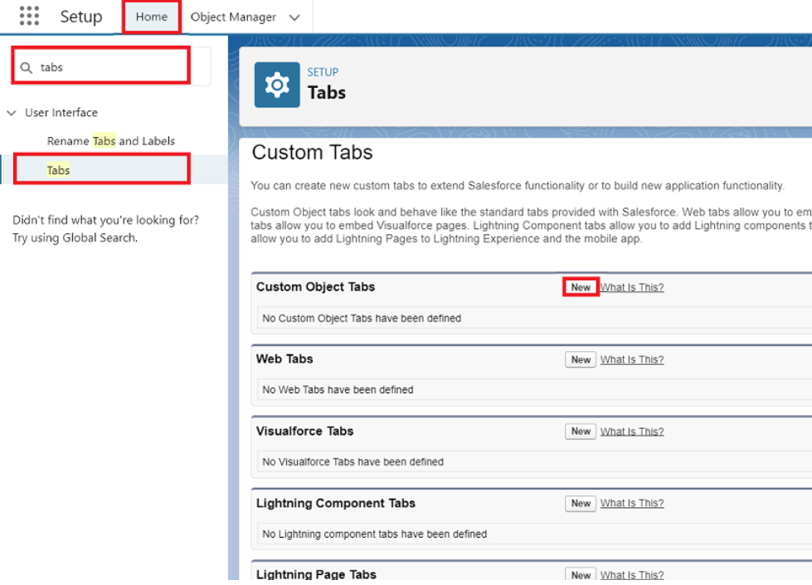

2) Select Object(HandsMen Customer) → Select any tab style → Next (Add to profiles page) keep it as default → Next (Add to Custom App) keep it as default → Save.

**Create a Lightning App:**

**To create a lightning app page:**

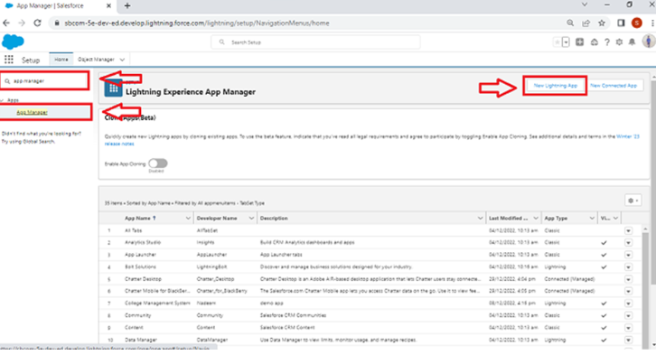

**1)App Details and Branding:**

* **App Name**: HandsMen Threads
* **Developer Name**: *(Auto-populated by Salesforce)*
* **Description**:

A modern and sophisticated men’s fashion platform built using Salesforce Developer Edition. This app offers seamless order management, customer engagement, inventory tracking, and personalized marketing using Lightning Web Components and Salesforce CRM tools.

* **Image**: *(Optional – You may skip it or upload a brand logo if available)*
* **Primary Color Hex Value**: #00A1E0 *(Keep the default, no spaces)*

2)Then click Next  → (App option page) keep it as default → Next → (Utility Items) keep it as default → Next.

* To Add Navigation Items:

Search the items in the search bar(HandsMen Customer, HandsMen Order, Inventory, HandsMen Product, Reports, Dashboard, Account, Contact , Marketing Campaign) from the search bar and move it using the arrow button → Next.  
**Note**: select the custom object which we have created in the previous activity.

* To Add User Profiles:

Search profiles (System administrator) in the search bar → click on the arrow button → save & finish.

**1. Order Confirmation Flow**

**Purpose:**

To automatically send a confirmation email to the customer when an order is successfully placed.

**Flow Type:**

*Record-Triggered Flow*

**Trigger:**

When a new **Order** record is created in the system.

**Flow Steps:**

* **Start**: Trigger when an Order record is created.
* **Get Records**: Retrieve the customer’s email and order details.
* **Send Email**: Use an Email Alert or Send Email action to notify the customer with order summary, delivery date, and contact info.
* **End**: Confirmation logged in the system.

**2. Low Stock Alert Flow**

**Purpose:**

To automatically alert inventory or sales staff when the stock for a product goes below a critical threshold (e.g., less than 10 units).

**Flow Type:**

*Scheduled Flow* or *Record-Triggered Flow*

**Trigger:**

When a Product Inventory record is updated and quantity is below the defined limit.

**Flow Steps:**

* **Start**: Trigger on update of Product or Inventory object.
* **Decision Element**: Check if Quantity < 10.
* **Send Notification**: Send an email or Slack alert to inventory team.
* **Update Field** *(optional)*: Update stock status to Low.
* **End**: Alert tracked for future audit.

**3. Loyalty Program Flow**

**Purpose:**

To reward customers with loyalty points after a successful purchase, encouraging repeat business.

**Flow Type:**

Record-Triggered Flow

**Trigger:**

When a new Order record is created and marked as Completed.

**Flow Steps:**

* **Start**: Trigger on Order creation or update.
* **Get Records**: Retrieve the customer profile.
* **Calculate Points**: Based on order amount (e.g., ₹1 = 1 point).
* **Update Records**: Add earned points to the customer’s loyalty score.
* **Optional Email**: Notify customer of updated loyalty points.
* **End**: Points added successfully.

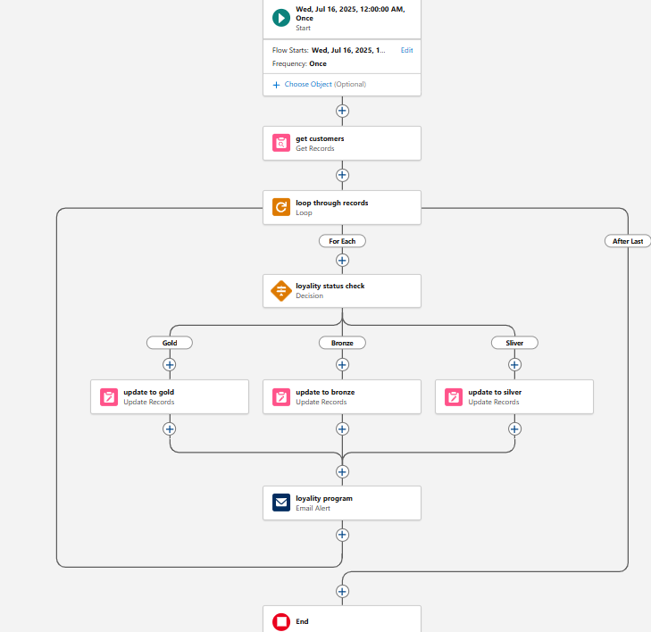

**Project Explanation with Real World Example:**

**Project Explanation:**

HandsMen Threads is a Salesforce-powered clothing retail management system designed specifically for a men’s fashion brand. It utilizes Salesforce’s Developer Edition to build a seamless customer experience and efficient business operations. The system covers key modules such as:

* Product Listings and Inventory Management
* Customer Order Handling
* Email Notifications for Order Confirmations
* Low Stock Alerts
* Loyalty Reward Program for Repeat Customers
* Custom Branded Lightning App Interface

It uses Lightning Web Components (LWC) to create interactive UI elements and Salesforce Flows to automate business processes without writing code.

The project demonstrates how a modern fashion brand can go beyond traditional retail and use cloud-based CRM to drive sales, improve customer experience, and streamline operations.

**Real-World Example:**

**Scenario:**

**Raghav** is a customer browsing the latest men’s fashion collection on the **HandsMen Threads** portal. He adds a designer shirt to his cart and places an order.

**What Happens Behind the Scenes:**

1. **Order Placement**:
   * Raghav submits his order.
   * The **Order Confirmation Flow** is triggered.
   * He receives an automated **email confirmation** thanking him for the purchase and sharing order details.
2. **Inventory Update**:
   * The system automatically deducts the purchased item from inventory.
   * If the remaining stock drops below 10, the **Low Stock Flow** triggers and alerts the warehouse team to reorder.
3. **Loyalty Program**:
   * Raghav earns loyalty points based on his order total (e.g., ₹2,000 = 2000 points).
   * His profile is updated, and he is notified of his points.
4. **Admin Dashboard**:
   * The admin logs into the **HandsMen Threads Lightning App**.
   * They view real-time data on inventory, customer orders, and loyalty summaries through custom LWC dashboards.

**Result:**

* **Customer Satisfaction**: Raghav is delighted by the prompt service and rewards.
* **Business Insight**: Admins track performance without manually calculating anything.
* **Efficiency**: Automated flows reduce manual intervention, leading to fewer errors and better resource planning.

**Outputs of the Project**

The **HandsMen Threads** project delivers multiple tangible and functional outputs through the Salesforce Developer Edition. These outputs reflect the implementation success of automation, CRM integration, and user interface development.

**🔹 1. Custom Branded App (Lightning App)**

* A visually styled **HandsMen Threads** Lightning App created using App Manager.
* Includes:
  + App logo (optional)
  + App branding color
  + Tab navigation for various modules (e.g., Products, Orders, Inventory)

**🔹 2. Order Confirmation Flow**

* Automatically sends an **email confirmation** to customers after a successful purchase.
* Ensures real-time communication with buyers.

**🔹 3. Low Stock Alert Flow**

* Triggers internal notifications when a product’s inventory falls below a threshold (e.g., less than 10 units).
* Helps in proactive restocking.

**🔹 4. Loyalty Program Flow**

* Tracks repeat customer purchases and **assigns loyalty points**.
* Points can later be used for discounts or promotions.

**🔹 5. Product Inventory Management**

* Admins can:
  + Add, edit, and delete products.
  + Monitor product availability.
  + View product-level stock status using standard and custom fields.

**🔹 6. Customer Orders Module**

* Enables tracking of customer orders from placement to delivery.
* Order data is stored securely and can be viewed or updated by administrators.

**🔹 7. Interactive User Interface via Lightning Web Components (LWC)**

* Clean and responsive components for admin and customer interaction.
* Examples:
  + Product Cards
  + Loyalty Point Display
  + Order Summary View

**🔹 8. Improved Customer Engagement**

* Real-time emails, loyalty rewards, and seamless ordering experience encourage return visits and customer satisfaction.

**🔹 9. Admin Dashboard**

* Provides a centralized view of:
  + Orders received
  + Inventory levels
  + Customer activity
  + Loyalty summaries

**Fig(a):**Creating HandsMen Threads Main Page

**Fig(b):**Order Conformation Email

**Fig©:**Low Stock Alert Email

**Fig(d):**Loyality Program

**Conclusion**

The **HandsMen Threads** project successfully showcases how a cloud-based CRM platform like Salesforce can be leveraged to build a modern, efficient, and scalable solution tailored to the needs of the fashion industry — especially for premium men’s fashion.

This project demonstrates not just theoretical implementation, but real-world application of **Salesforce Developer Edition** tools like **Lightning Web Components (LWC)**, **Flow Automation**, and **CRM Customization**. Here's what makes this project impactful:

**Key Takeaways:**

* **Seamless Business Operations**: From order confirmation to inventory monitoring and customer loyalty, each business function is automated using Salesforce flows.
* **Custom App Branding**: The app reflects a professional and sophisticated identity with branded visuals, meaningful descriptions, and consistent UI styling.
* **Lightning Web Components**: Used to create responsive, fast, and reusable UI components, enabling an engaging and interactive user experience.
* **Data Centralization**: All key business data — customers, orders, inventory — is managed within Salesforce CRM, reducing manual processes.
* **Real-World Simulation**: The system mirrors how an actual retail fashion business operates, handling tasks like order tracking, low stock alerts, and rewarding repeat customers.
* **Scalability**: The app is designed to grow with the business — more features, more users, more data — all manageable from a single CRM interface.
* **Customer-Centric Design**: Through flows and CRM logic, the platform keeps customer satisfaction at the core — from timely confirmations to loyalty rewards.
* **Low-Code Platform**: Built entirely within Salesforce Developer Edition using mostly declarative tools and limited code, showcasing how non-developers can also build powerful apps.
* **Integration Ready**: Can be extended in the future to connect with e-commerce platforms, payment gateways, or marketing tools using Salesforce APIs.
* **Best Practices**: Follows Salesforce-recommended best practices for automation, UI building, and component management.

**Final Thoughts:**

HandsMen Threads isn't just a project — it's a **blueprint for how modern retail brands** can **digitally transform** using Salesforce. By building everything on the Salesforce cloud, it brings together functionality, branding, automation, and scalability in one platform.

It also proves how even a beginner with Salesforce Developer Edition can **build enterprise-grade apps** with visual tools and thoughtful planning.

This project sets a foundation for further innovation, such as:

* AI-powered fashion suggestions,
* Automated return/refund systems,
* Integrated marketing campaigns,
* And customer service chatbots.